**Prescription Database**

**IFSC 3330: Current Trends In Database Technology**

**Bryan Fendley**

**PHASE 1: Database description** **3**

**ER Diagram** **4**

**PHASE 2: Schema and functional dependencies** **5**

**PHASE 3: SQL code to create and populate tables** **7**

**Manufacturer** **7**

**Drug** **8**

**Employee** **9**

**Pharmacy** **11**

**Patient** **12**

**Doctor** **13**

**Prescription** **14**

**PHASE 4: SQL queries and their results** **16**

**Select the average salary of male employees.** **16**

**Retrieve the names of patients that Esmiralda Meyers is working on.** **17**

**Find the total number of patients that Boris Hamilton is working on.** **18**

**What is the name of the manufacturer located in monticello?** **19**

**What drug class is Fentanyl?** **20**

**Find the names of drugs that are opiods and list their manufacturer.** **21**

**For the pharmacies located in Arizona, list the names of the employees.** **22**

**For each drug, list it’s drug type, and manufacturer name.** **23**

# **PHASE 1:** Database description

* This database represents the entities and relationships between those involved in pharmaceutical operations.
* Covering data from the creation of the drug through all that will handle it until it ends up in the patient’s possession.
* This situation features seven entities consisting of: Pharmacy, Employee, Drug, Manufacturer, Prescription, Patient, and Doctor.
* The relationships between these entities begin with the Drug Manufacturer producing a Drug.
* This Drug is prescribed by a Doctor, after this Doctor diagnoses the Patient.
* The Patient then Receives the Drug from the Employee who works at the Pharmacy.
* The Patient cannot get the Drug directly from the Manufacturer, nor can the Doctor.
* It must go through the Pharmacy first and be handled by the Employee.
* One Doctor prescribes many Drugs.
* One Manufacturer produces many Drugs.
* This same Manufacturer ships this Drug to many Pharmacy locations.
* This one Pharmacy has many Employees working at it.
* One Patient receives many Drugs which are handled by many Employees before being received by the Patient.

# ER Diagram

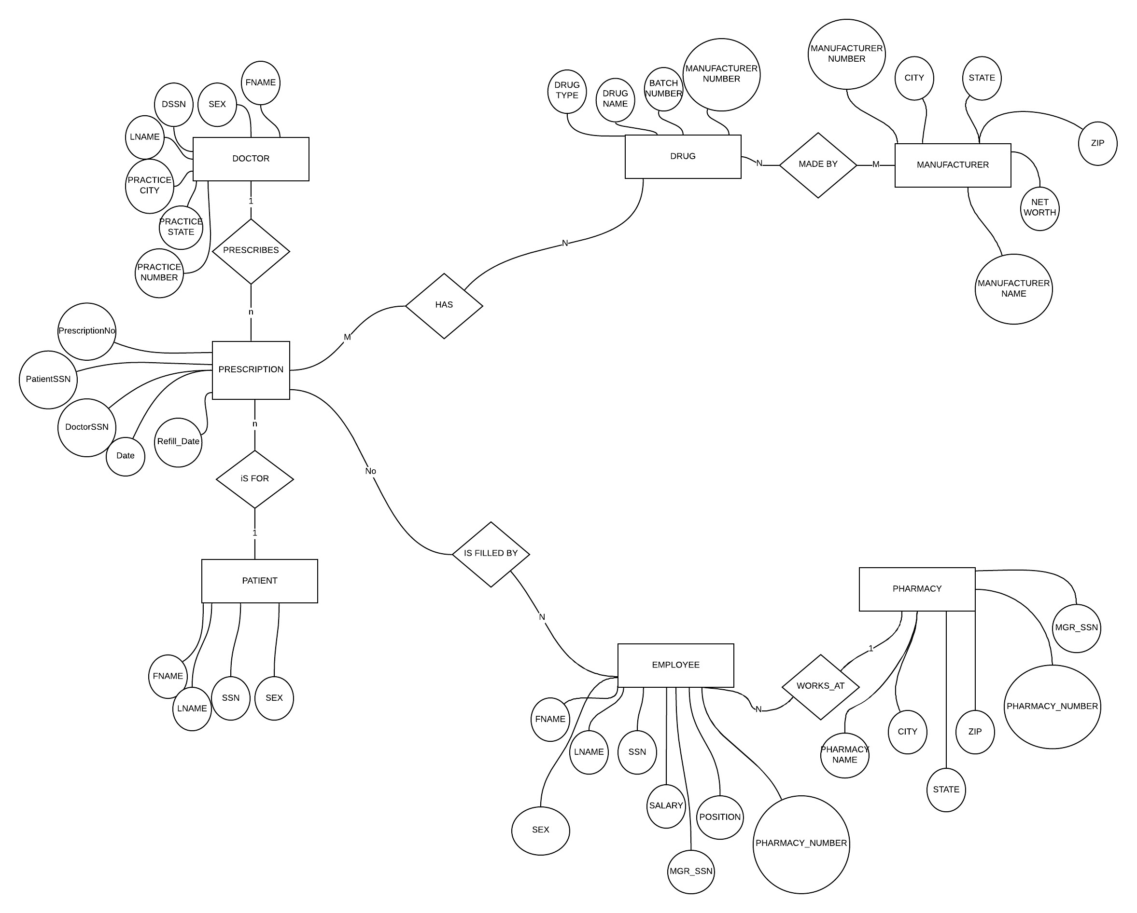

# **PHASE 2:** Schema and functional dependencies

* DOCTOR(Fname, Lname, SSN, Sex, Practice_City, State, PracticeNo)(3nf)
* PRESCRIPTION(PrescriptionNo, PatientSSN, DoctorSSN, Date, Refill_Date)(3nf)
* PATIENTS(SSN, Fname, Lname, Sex)(3nf)
* EMPLOYEE(Fname, Lname, Sex, SSN, Salary, Position, Mgr_SSN, PharmacyNo)(3nf)
* PHARMACY(Name, City, State, Zip, Mgr_SSN, PharmacyNo)(3nf)
* MANUFACTURER(Manufacturer_No, Manufacturer_name, City, State, Zip, Networth)(3nf)
* DRUG(Type, Name, BatchNo, ManufacturerNo)(3nf)

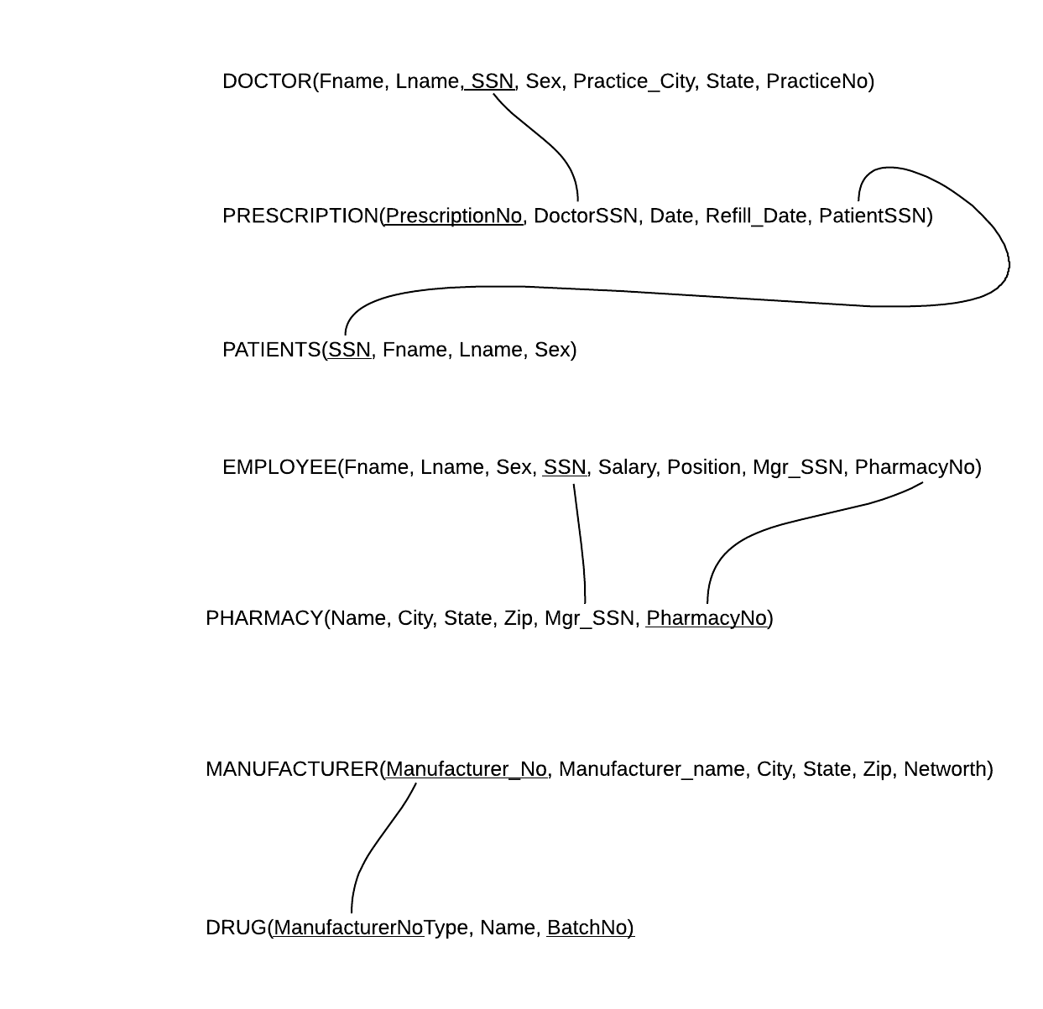

# **PHASE 3:** SQL code to create and populate tables

# Manufacturer

drop table Manufacturer cascade constraints;

Create table Manufacturer (

ManufacturerNo number(10) not null,

ManufacturerName varchar2(30) not null,

City varchar2(40) not null,

Stateabbreviated varchar2(2) not null,

Zip number(5) not null,

NetWorth number(38) not null,

Primary key (ManufacturerNo));

* INSERT INTO Manufacturer (ManufacturerNo, ManufacturerName, City, Stateabbreviated, Zip, NetWorth) values(3745464638, 'Rancorp', 'Monticello', 'AR', 71655, 444911110);
* INSERT INTO Manufacturer (ManufacturerNo, ManufacturerName, City, Stateabbreviated, Zip, NetWorth) values(2434569584, 'Grenko', 'Akron', 'OH', 44223, 499431111);
* INSERT INTO Manufacturer (ManufacturerNo, ManufacturerName, City, Stateabbreviated, Zip, NetWorth) values(1834663857, 'Xantech', 'Seattle', 'WA', 98101, 433411110);
* INSERT INTO Manufacturer (ManufacturerNo, ManufacturerName, City, Stateabbreviated, Zip, NetWorth) values(3928564328, 'Perkins', 'Phoenix', 'AZ', 85111, 994111111);
* INSERT INTO Manufacturer (ManufacturerNo, ManufacturerName, City, Stateabbreviated, Zip, NetWorth) values(2847463758, 'Purdue', 'Dallas', 'TX', 75111, 325111111);
* INSERT INTO Manufacturer (ManufacturerNo, ManufacturerName, City, Stateabbreviated, Zip, NetWorth) values(1393464943, 'Delmond', 'Detroit', 'MI', 48203, 564111111);

# Drug

drop table Drug cascade constraints;

Create table Drug (

BatchNo number(10) not null,

ManufacturerNo number(10) not null,

DrugName varchar2(40) not null,

DrugType varchar2(40) not null,

Primary key(BatchNo, ManufacturerNo),

Foreign key (ManufacturerNo) references Manufacturer);

* INSERT INTO Drug (BatchNo, ManufacturerNo, DrugName, DrugType) values (9911993324, 3745464638, 'Oxycodone', 'Opioid');
* INSERT INTO Drug (BatchNo, ManufacturerNo, DrugName, DrugType) values (2211122344, 2434569584, 'Alprazolam', 'Benzodiazepine');
* INSERT INTO Drug (BatchNo, ManufacturerNo, DrugName, DrugType) values (6634534523, 1834663857, 'Promethazine', 'Antihistamine');
* INSERT INTO Drug (BatchNo, ManufacturerNo, DrugName, DrugType) values (7878645453, 3745464638, 'Diazepam', 'Benzodiazepine');
* INSERT INTO Drug (BatchNo, ManufacturerNo, DrugName, DrugType) values (3463745685, 3928564328, 'Fentanyl', 'Opioid');
* INSERT INTO Drug (BatchNo, ManufacturerNo, DrugName, DrugType) values (0293899933, 2434569584, 'Quetiapine', 'Antipsychotic');
* INSERT INTO Drug (BatchNo, ManufacturerNo, DrugName, DrugType) values (2936346349, 2847463758, 'Escitalopram', 'SSRI' );
* INSERT INTO Drug (BatchNo, ManufacturerNo, DrugName, DrugType) values (2223543444, 2847463758, 'Lisdexamfetamine', 'Stimulant' );
* INSERT INTO Drug (BatchNo, ManufacturerNo, DrugName, DrugType) values (6234252323, 1393464943, 'Oseltamivir', 'Antiviral' );

# Employee

drop table Employee cascade constraints;

Create table Employee (

Ssn number(9) not null,

Sex char(1),

Fname varchar2(40) not null,

Lname varchar2(40) not null,

Salary number(38) not null,

MgrSsn number(9) not null,

Position varchar2(40) not null,

PharmacyNo number(10) not null,

primary key (Ssn),

constraint Sex_ck check (Sex = 'F' or Sex='M'));

* INSERT INTO Employee (Ssn, Sex, Fname, Lname, Salary, MgrSsn, Position, PharmacyNo) values (234234221, 'F', 'Cheryl', 'Anderson',33110 , 435113553, 'Stocker', 999111222);
* INSERT INTO Employee (Ssn, Sex, Fname, Lname, Salary, MgrSsn, Position, PharmacyNo) values (948575638, 'M', 'Chris', 'Singleton', 88110, 435113553, 'Technichian', 999111222);
* INSERT INTO Employee (Ssn, Sex, Fname, Lname, Salary, MgrSsn, Position, PharmacyNo) values (435113553, 'F', 'Natalie', 'Lions', 131111, 435113553, 'Manager', 999111222);
* INSERT INTO Employee (Ssn, Sex, Fname, Lname, Salary, MgrSsn, Position, PharmacyNo) values (958775904, 'F', 'Krystal', 'Tranham', 24110, 435113553, 'Cashier', 999111222);
* INSERT INTO Employee (Ssn, Sex, Fname, Lname, Salary, MgrSsn, Position, PharmacyNo) values (332444222, 'M', 'Alexander', 'Davidson', 44110, 994884774, 'Technichian', 889966335);
* INSERT INTO Employee (Ssn, Sex, Fname, Lname, Salary, MgrSsn, Position, PharmacyNo) values (994884774, 'M', 'Steven', 'Canitelli', 181111, 994884774, 'Manager', 889966335);
* INSERT INTO Employee (Ssn, Sex, Fname, Lname, Salary, MgrSsn, Position, PharmacyNo) values (435221553, 'F', 'Michelle', 'Lee', 131111, 994884774, 'Stocker', 889966335);
* INSERT INTO Employee (Ssn, Sex, Fname, Lname, Salary, MgrSsn, Position, PharmacyNo) values (112444112, 'M', 'Mitchell', 'Adams', 131111, 994884774, 'Cashier', 889966335);
* INSERT INTO Employee (Ssn, Sex, Fname, Lname, Salary, MgrSsn, Position, PharmacyNo) values (848389938, 'M', 'Gerald', 'Myers', 99110, 945822309, 'Technichian', 662245222);
* INSERT INTO Employee (Ssn, Sex, Fname, Lname, Salary, MgrSsn, Position, PharmacyNo) values (945822309, 'M', 'Benjamin', 'Bannicker', 131111, 945822309, 'Manager', 662245222);
* INSERT INTO Employee (Ssn, Sex, Fname, Lname, Salary, MgrSsn, Position, PharmacyNo) values (990833215, 'F', 'Emily', 'Northbend', 51110, 945822309, 'Cashier', 662245222);
* INSERT INTO Employee (Ssn, Sex, Fname, Lname, Salary, MgrSsn, Position, PharmacyNo) values (990838765, 'F', 'Lauren', 'Reinhardt', 121110, 945822309, 'Stocker', 662245222);
* INSERT INTO Employee (Ssn, Sex, Fname, Lname, Salary, MgrSsn, Position, PharmacyNo) values (990887455, 'F', 'Jennifer', 'Jenkins', 12110, 985544374, 'Intern', 122333441);
* INSERT INTO Employee (Ssn, Sex, Fname, Lname, Salary, MgrSsn, Position, PharmacyNo) values (958663322, 'F', 'Tiana', 'Williams', 24110, 985544374, 'Cashier', 122333441);
* INSERT INTO Employee (Ssn, Sex, Fname, Lname, Salary, MgrSsn, Position, PharmacyNo) values (332352222, 'M', 'David', 'Rodriguez', 44110, 985544374, 'Stocker', 122333441);
* INSERT INTO Employee (Ssn, Sex, Fname, Lname, Salary, MgrSsn, Position, PharmacyNo) values (985544374, 'M', 'Wilson', 'Pearsons', 181111, 985544374, 'Manager', 122333441);

# Pharmacy

drop table Pharmacy cascade constraints;

Create table Pharmacy (

PharmacyNo number(10) not null,

PharmacyName varchar2(20) not null,

MgrSsn number(9) not null,

City varchar2(20) not null,

Stateabbreviated varchar2(2) not null,

Zip number(5) not null,

primary key (PharmacyNo),

foreign key (MgrSsn) references Employee);

* INSERT INTO Pharmacy (PharmacyNo, PharmacyName, MgrSsn, City, Stateabbreviated, Zip) values (122333441, 'Pharma World', 985544374, 'Dallas', 'TX', 75111);
* INSERT INTO pharmacy (PharmacyNo, PharmacyName, MgrSsn, City, Stateabbreviated, Zip) values (662245222, 'Pill Palace', 945822309, 'Dallas', 'TX', 75111);
* INSERT INTO pharmacy (PharmacyNo, PharmacyName, MgrSsn, City, Stateabbreviated, Zip) values (889966335, 'Rx Emporium', 994884774, 'Monticello', 'AR', 71655 );
* INSERT INTO pharmacy (PharmacyNo, PharmacyName, MgrSsn, City, Stateabbreviated, Zip) values (999111222, 'Prescription Pad', 435113553, 'Phoenix', 'AZ', 85111 );

# Patient

drop table Patient cascade constraints;

Create table Patient (

Ssn number(9) not null,

Sex char(1),

Fname varchar2(40) not null,

Lname varchar2(40) not null,

primary key (Ssn),

constraint Sex_chk check (Sex = 'F' or Sex='M'));

* INSERT INTO Patient (Ssn, Sex, Fname, Lname) values (111110898, 'F', 'Jenny', 'Watson');
* INSERT INTO Patient (Ssn, Sex, Fname, Lname) values (111110332, 'F', 'Oliva', 'Princeton');
* INSERT INTO Patient (Ssn, Sex, Fname, Lname) values (333552223, 'F', 'Lauren', 'Williams');
* INSERT INTO Patient (Ssn, Sex, Fname, Lname) values (111199228, 'F', 'Jennifer', 'Taylor');
* INSERT INTO Patient (Ssn, Sex, Fname, Lname) values (449933882, 'F', 'Rhonda', 'Johnson');
* INSERT INTO Patient (Ssn, Sex, Fname, Lname) values (119988773, 'M', 'Thomas', 'Ramone');
* INSERT INTO Patient (Ssn, Sex, Fname, Lname) values (378273849, 'M', 'Patrick', 'Smith');
* INSERT INTO Patient (Ssn, Sex, Fname, Lname) values (234234234, 'M', 'Richard', 'Rolfe');
* INSERT INTO Patient (Ssn, Sex, Fname, Lname) values (775544556, 'M', 'Edward', 'Swimmington');
* INSERT INTO Patient (Ssn, Sex, Fname, Lname) values (887799888, 'M', 'Jeff', 'Rogers');

# Doctor

drop table Doctor cascade constraints;

create table Doctor (

Ssn number(9) not null,

Sex char(1),

Fname varchar2(40) not null,

Lname varchar2(40) not null,

PracticeNo number(10),

PracticeCity varchar2(20) not null,

PracticeState varchar2(2) not null,

PracticeZip number(5) not null,

primary key (Ssn),

constraint Sex_cbk check (Sex = 'F' or Sex='M'));

* INSERT INTO Doctor (Ssn, Sex, Fname, Lname, PracticeNo, PracticeCity, PracticeState, PracticeZip) values (11123233, 'F', 'Esmiralda', 'Meyers', 1111112211, 'Phoenix', 'AZ', 85111 );
* INSERT INTO Doctor (Ssn, Sex, Fname, Lname, PracticeNo, PracticeCity, PracticeState, PracticeZip) values (99119933, 'F', 'Yolanda', 'Leggette', 2222220221, 'Dallas', 'TX', 75111 );
* INSERT INTO Doctor (Ssn, Sex, Fname, Lname, PracticeNo, PracticeCity, PracticeState, PracticeZip) values (12212214, 'M', 'Boris', 'Hamilton', 2101221221, 'Dallas', 'TX', 75111 );
* INSERT INTO Doctor (Ssn, Sex, Fname, Lname, PracticeNo, PracticeCity, PracticeState, PracticeZip) values (55443355, 'M', 'Leonardo', 'Brovlosky', 1124899099, 'Monticello', 'AR', 71655);

# Prescription

drop table Prescription cascade constraints;

Create table Prescription (

PrescriptionNo number(10) not null,

PatientSsn number(9) not null,

DoctorSsn number(9) not null,

PharmacyNo number(10) not null,

PickupDate date,

RefillDate date,

primary key (PrescriptionNo),

foreign key (PatientSsn) references Patient,

foreign key (PharmacyNo) references Pharmacy,

foreign key (DoctorSsn) references Doctor);

* INSERT INTO Prescription (PrescriptionNo, PatientSsn, DoctorSsn, PharmacyNo, PickupDate, RefillDate) values (111221202, 111110898, 11123233, 999111222, To_Date( '02-02-2020', ' mm/dd/yyyy'), To_Date( '03-02-2021', 'mm/dd/yyyy'));
* INSERT INTO Prescription (PrescriptionNo, PatientSsn, DoctorSsn, PharmacyNo, PickupDate, RefillDate) values (113111404, 111110332, 11123233, 999111222, To_Date( '02-02-2020', ' mm/dd/yyyy'), To_Date( '04-02-2021', 'mm/dd/yyyy'));
* INSERT INTO Prescription (PrescriptionNo, PatientSsn, DoctorSsn, PharmacyNo, PickupDate, RefillDate) values (111911194, 333552223, 11123233, 999111222, To_Date( '01-02-2020', ' mm/dd/yyyy'), To_Date( '02-02-2021', 'mm/dd/yyyy'));
* INSERT INTO Prescription (PrescriptionNo, PatientSsn, DoctorSsn, PharmacyNo, PickupDate, RefillDate) values (111292874, 111199228, 99119933, 662245222 , To_Date( '01-02-2020', ' mm/dd/yyyy'), To_Date( '03-02-2021', 'mm/dd/yyyy'));
* INSERT INTO Prescription (PrescriptionNo, PatientSsn, DoctorSsn, PharmacyNo, PickupDate, RefillDate) values (3332223322, 449933882, 99119933, 662245222, To_Date( '01-02-2020', ' mm/dd/yyyy'), To_Date( '04-02-2021', 'mm/dd/yyyy'));
* INSERT INTO Prescription (PrescriptionNo, PatientSsn, DoctorSsn, PharmacyNo, PickupDate, RefillDate) values (222112221,119988773, 99119933, 662245222, To_Date( '01-02-2020', ' mm/dd/yyyy'), To_Date( '02-02-2021', 'mm/dd/yyyy'));
* INSERT INTO Prescription (PrescriptionNo, PatientSsn, DoctorSsn, PharmacyNo, PickupDate, RefillDate) values (111998887, 378273849, 12212214, 122333441, To_Date( '06-02-2020', ' mm/dd/yyyy'), To_Date( '12-02-2021', 'mm/dd/yyyy'));
* INSERT INTO Prescription (PrescriptionNo, PatientSsn, DoctorSsn, PharmacyNo, PickupDate, RefillDate) values (667776667, 234234234, 12212214, 122333441, To_Date( '08-02-2020', ' mm/dd/yyyy'), To_Date( '12-02-2021', 'mm/dd/yyyy'));
* INSERT INTO Prescription (PrescriptionNo, PatientSsn, DoctorSsn, PharmacyNo, PickupDate, RefillDate) values (8884447776, 775544556, 55443355, 889966335, To_Date( '02-01-2020', ' mm/dd/yyyy'), To_Date( '02-06-2021', 'mm/dd/yyyy'));
* INSERT INTO Prescription (PrescriptionNo, PatientSsn, DoctorSsn, PharmacyNo, PickupDate, RefillDate) values (335566745, 887799888, 55443355, 889966335, To_Date( '02-01-2020', ' mm/dd/yyyy'), To_Date( '02-06-2021', 'mm/dd/yyyy'));

# **PHASE 4:** SQL queries and their results

# Select the average salary of male employees.

**SELECT AVG(salary)**

**FROM EMPLOYEE**

**WHERE sex='M';**

**Result**

**AVG(SALARY)**

**-----------**

**112485.5**

# Retrieve the names of patients that Esmiralda Meyers is working on.

**SELECT patient.Fname, patient.Lname**

**FROM PATIENT, PRESCRIPTION**

**WHERE DoctorSsn=11123233 AND Patient.Ssn=PatientSsn;**

**Result**

**FNAME LNAME**

**---------------------------------------- ----------------------------------------**

**Jenny Watson**

**Oliva Princeton**

**Lauren Williams**

# Find the total number of patients that Boris Hamilton is working on.

**SELECT COUNT(*)**

**FROM PRESCRIPTION, DOCTOR**

**WHERE DoctorSsn=DOCTOR.Ssn AND Doctor.Fname='Boris' AND Doctor.Lname='Hamilton';**

**Result**

**COUNT(*)**

**----------**

**2**

# What is the name of the manufacturer located in monticello?

**SELECT ManufacturerName**

**FROM MANUFACTURER**

**WHERE City = ‘Monticello’;**

**Result**

**MANUFACTURERNAME**

**------------------------------**

**Rancorp**

# What drug class is Fentanyl?

**SELECT DrugType  
  
FROM DRUG  
  
WHERE DrugName = ‘Fentanyl’;**

**Result**

**DRUGTYPE**

**----------------------------------------**

**Opioid**

# Find the names of drugs that are opiods and list their manufacturer.

**SELECT DrugName, DrugType, ManufacturerName**

**FROM DRUG, MANUFACTURER**

**WHERE DRUG.ManufacturerNo = MANUFACTURER.ManufacturerNo AND DrugType = 'Opioid';**

**Result**

**DRUGNAME DRUGTYPE MANUFACTURERNAME**

**---------------------------------------- ---------------------------------------- ------------------------------**

**Oxycodone Opioid Rancorp**

**Fentanyl Opioid Perkins**

# For the pharmacies located in Arizona, list the names of the employees.

**SELECT Fname, Lname**

**FROM EMPLOYEE, PHARMACY**

**WHERE Pharmacy.MgrSsn=Employee.MgrSsn AND Stateabbreviated='AZ';**

**Result**

**FNAME LNAME**

**---------------------------------------- ----------------------------------------**

**Cheryl Anderson**

**Chris Singleton**

**Natalie Lions**

**Krystal Tranham**

# For each drug, list it’s drug type, and manufacturer name.

**SELECT DrugName, DrugType, ManufacturerName**

**FROM DRUG, MANUFACTURER**

**WHERE DRUG.ManufacturerNo = MANUFACTURER.ManufacturerNo;**

**Result**

**DRUGNAME DRUGTYPE MANUFACTURERNAME**

**---------------------------------------- ---------------------------------------- ------------------------------**

**Oxycodone Opioid Rancorp**

**Alprazolam Benzodiazepine Grenko**

**Promethazine Antihistamine Xantech**

**Diazepam Benzodiazepine Rancorp**

**Fentanyl Opioid Perkins**

**Quetiapine Antipsychotic Grenko**

**Escitalopram SSRI Purdue**

**Lisdexamfetamine Stimulant Purdue**

**Oseltamivir Antiviral Delmond**